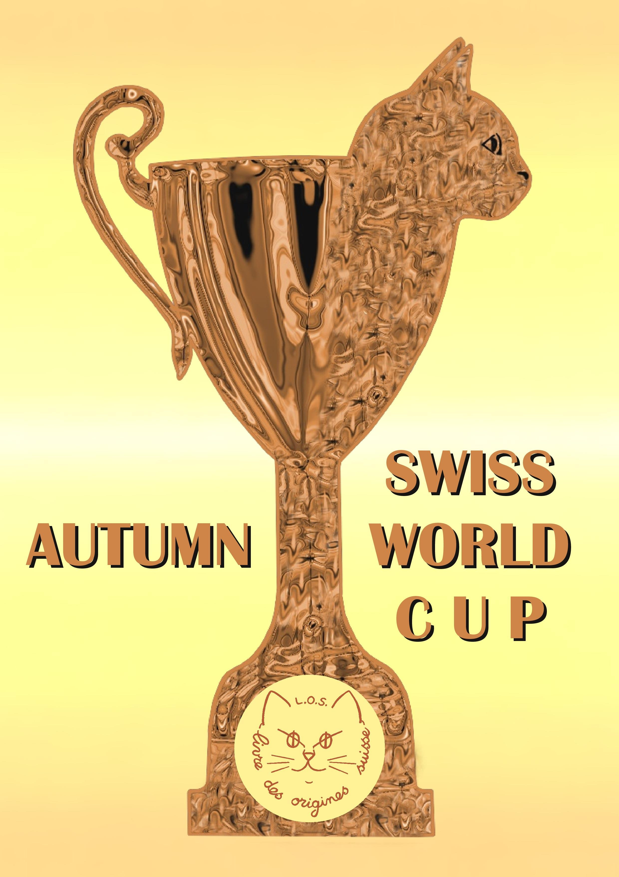On the occasion of the 85th anniversary of the Cat-Club de Genève, the Swiss pedigree record (Livre des origines suisse) is organising
THE FIRST FELINE WORLD CHAMPIONSHIP
open to all federations in all countries:

The first edition of the SAWC will take place
during the CCG cat show in Palexpo Geneva
on November 3rd and 4th 2018.

Founded in 1933, the Cat Club de Genève (CCG) is one of the three oldest cat clubs in the world, along with the Cat Fanciers’ Association (CFA, USA) and the Governing Council of the Cat Fancy (GCCF, Great-Britain).

On the occasion of its 85th anniversary, the Cat Club de Genève is organising the Swiss Autumn World Cup, a trophy created by its Livre des origines suisse (LOS). This trophy will be awarded every autumn during the most important Swiss cat show of the year, namely the CCG show on the occasion of the Automnales exhibition at Palexpo Geneva.

This is the first distinction on such a level that is open to cats of all federations, of all countries. The first edition will take place on November 3rd and 4th, during the cat show of the CCG at Palexpo Geneva.

The SAWC is therefore as of now the highest reward that a cat who is competing on an international level can receive in Switzerland. Only cats who have obtained the following titles during the 10 years preceding the competition, in any country of the world, may participate:

Grand Champion of Europe - GCE (for independent clubs), Grand Champion - GC (for CFA), Supreme Grand Champion - SGC (for TICA) and Champion Supreme - CS (for FIFE)

Shorthairs, semi-longhairs and longhairs compete together. They can be males, females, neutered males or females; these 4 categories also compete together.

For the first edition of the SAWC, the number of participants is limited to 80 cats.

The judges will officiate in public, in the show hall, starting Saturday morning. The international allbreed judge, assisted by a clerk, will hold an American style ring to select and evaluate the cats.

After having judged all the cats in competition, the SAWC judge will establish the ranking of his 10 best cats, that he will announce on Sunday afternoon during the finale, which will start at 2:30 PM on the stage.

The ranking of the 10 finalists will be announced by the judge, who will present each cat to the public, starting with the 10th best and ending with the 1st.

The best cat will be declared World Champion.

The best of each of the other two hair categories (for instance the best longhair and the best shorthair if the champion is a semi-longhair) will be proclaimed Vice World Champion in his or her hair category.

The decisions of the judge cannot be contested.

